**Air Quality Monitoring**

# **Introduction:**

# In recent years, urban areas have experienced a significant increase in air pollution, leading to adverse health effects and environmental degradation. To address this critical issue, the City of Greenville implemented an advanced Air Quality Monitoring System (AQMS) aimed at real-time monitoring, analysis, and control of air pollutants. This case study explores the implementation process, challenges faced, and the impact of the AQMS on the city's environment and public health.

# **Objectives:**

# Real-Time Monitoring: Develop a comprehensive system for continuous monitoring of air quality parameters including particulate matter (PM2.5 and PM10), nitrogen dioxide (NO2), sulfur dioxide (SO2), carbon monoxide (CO), ozone (O3), and volatile organic compounds (VOCs).

# Data Analysis: Implement robust data analysis algorithms to process the collected data and identify pollution patterns, sources, and trends.

# Public Awareness: Utilize the collected data to create awareness among citizens about air quality issues and promote environmentally friendly practices.

# 

# 

# **Implementation:**

# Sensor Deployment: High-quality air quality sensors were strategically deployed across the city, covering residential, industrial, and commercial zones. These sensors continuously collected data and transmitted it to a central server.

# Data Analysis: Advanced machine learning algorithms were employed to process the raw sensor data. This allowed the identification of pollution hotspots, correlation with weather patterns, and prediction of potential pollution events.

# Public Engagement: A user-friendly mobile application and website were developed, providing citizens with real-time air quality updates, health recommendations, and pollution alerts. Social media platforms were also utilized for wider outreach.

# **Challenges Faced:**

# Data Accuracy: Ensuring the accuracy and calibration of sensors posed a challenge. Regular maintenance and calibration protocols were implemented to address this issue.

# Data Security: Safeguarding the collected data against cyber threats and ensuring the privacy of citizens were paramount. Robust encryption techniques and strict access controls were implemented.

# Public Participation: Encouraging citizens to actively engage with the AQMS and change their behaviors based on air quality data proved challenging. Extensive awareness campaigns and community workshops were organized.

# 

**Flowchart:**

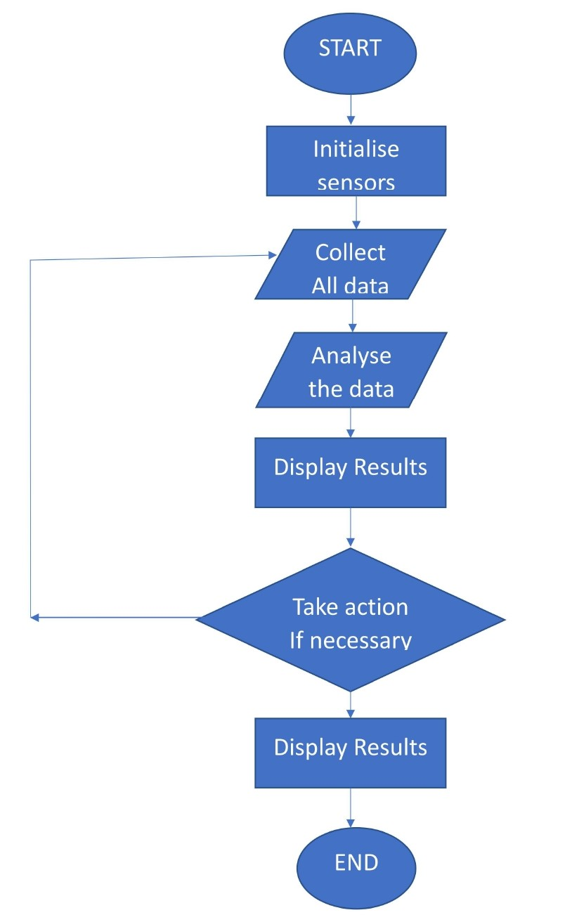

**STEPS FOR FLOWCHART:**

STEP 1: Start the program.

STEP 2: Turn on the Gas, Temperature and Humidity sensors.

STEP 3: Collect the data:

1. Read gas concentration.
2. Measure temperature and humidity level.

STEP 4: Analyze Data:

1. Check if gas concentration is within safe limits.
2. Check if temperature and humidity is within comfort range.

STEP 5: Display results:

1. Show gas concentration on display.
2. Show temperature value on display.
3. Show humidity percentage.

STEP 6: Take action (if necessary):

1. If gas concentration is high, activate alarm or ventilation.
2. If the temperature is too high or low, adjust the heating or cooling system.
3. If the humidity is too high or low, activate the dehumidifier or humidifier.

STEP 7: Wait for a set time.

STEP 8: Repeat 3-7 continuously.

STEP 9: End the program.

**Block diagram:**

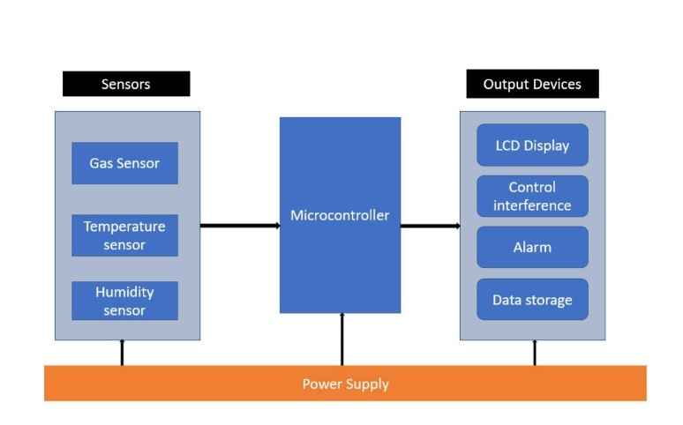

**Block Diagram Description:**

1. Microcontroller/Main Processing Unit: This is the brain of the system, collecting data from sensors and processing it and managing output actions and displays.

2. Sensors: - Gas Sensor: Connects to the microcontroller and detects specific gasses. - Temperature Sensor: Connects to the microcontroller to measure temperature. - Humidity Sensor: Connects to the microcontroller to measure humidity.

3.Communication Interface: Enables the microcontroller to communicate with external devices or a computer. This can be Wi-Fi, Bluetooth, or wired connections like USB or Ethernet.

4. Display: Shows real-time data readings, alerts, or system status.

5. Alarm/Notification System: This can be an audible alarm, LED indicator, or any other signaling device that alerts the user when air quality goes outside the desired range.

6. Power Supply: Provides power to the entire system. This could be batteries, solar panels, or a direct power source.

7. Data Storage: Where the data can be logged for historical analysis. This could be an SD card, onboard memory, or cloud storage.

8. Control Buttons/Interface: Allows the user to interact with the system, set thresholds, or view historical data.

**Circuit Diagram:**

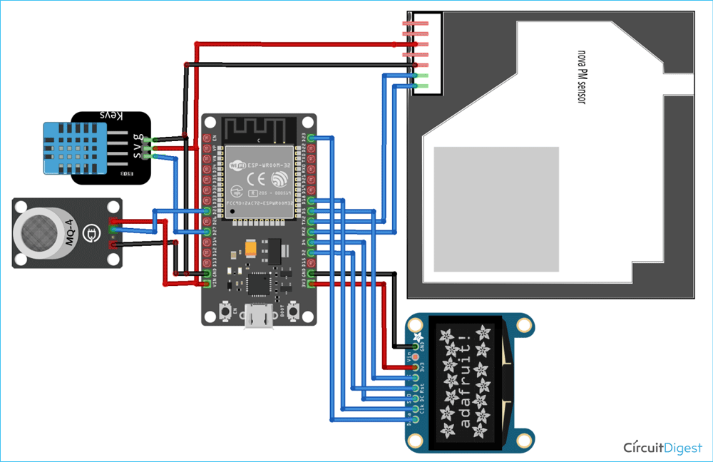

### **COMPONENTS REQUIRED:**

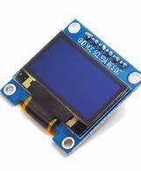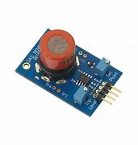 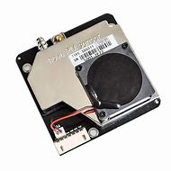

MQ-7 Sensor DHT11 Sensor OLED Display PM Sensor

**APPLICATION:**

1. Monitor air in urban areas to ensure it is safe to breathe.
2. Detects harmful substances like CO2, Greenhouse gasses and volatile organic compounds.
3. Inform farmers about best time of plant or harvest based on air quality.

**Conclusion:**

The implementation of an advanced Air Quality Monitoring System not only improved the city's air quality but also enhanced public awareness and policy decisions. By leveraging technology and community engagement, the City of Greenville successfully tackled the pressing issue of air pollution, creating a healthier and sustainable environment for its residents.